**Title: Fluorescence lifetime imaging detects long-lifetime signal associated with reduced pyocyanin at the surface of *P. aeruginosa* biofilms and in cross-feeding conditions**

T. Gallagher*, S.W. Leemans*, A. Dvornikov, K. Perinbam, J. Fong, C. Kim, J. Kapcia, M. Kagawa, A. Grosvirt-Dramen, A. Hochbaum, M. Digman, E. Gratton, A. Siryaporn, K. Whiteson

Supplemental Figures

**Figure S1**: Two-photon fluorescence emission spectra of *P. aeruginosa* fluorophores characterized with a hyperspectral imaging microscope (excitation = 740 nm, emission window = 400-690 nm). The florescence emission spectra were normalized by max peak intensity of fluorophores. The gray window (400-500 nm) represents the emission filter used for downstream image acquisition of bacterial samples with the DIVER FLIM microscope. CPX = coproporphyrin, FAD = flavin adenine dinucleotide, NADH = nicotinamide adenine dinucleotide hydrogen, OHPhz = 1-hydroxyphenazine, PCA = phenazine-1-carboxylic acid, PCN = phenazine-1-carboxamide, PVD = pyoverdine, PYO = pyocyanin.

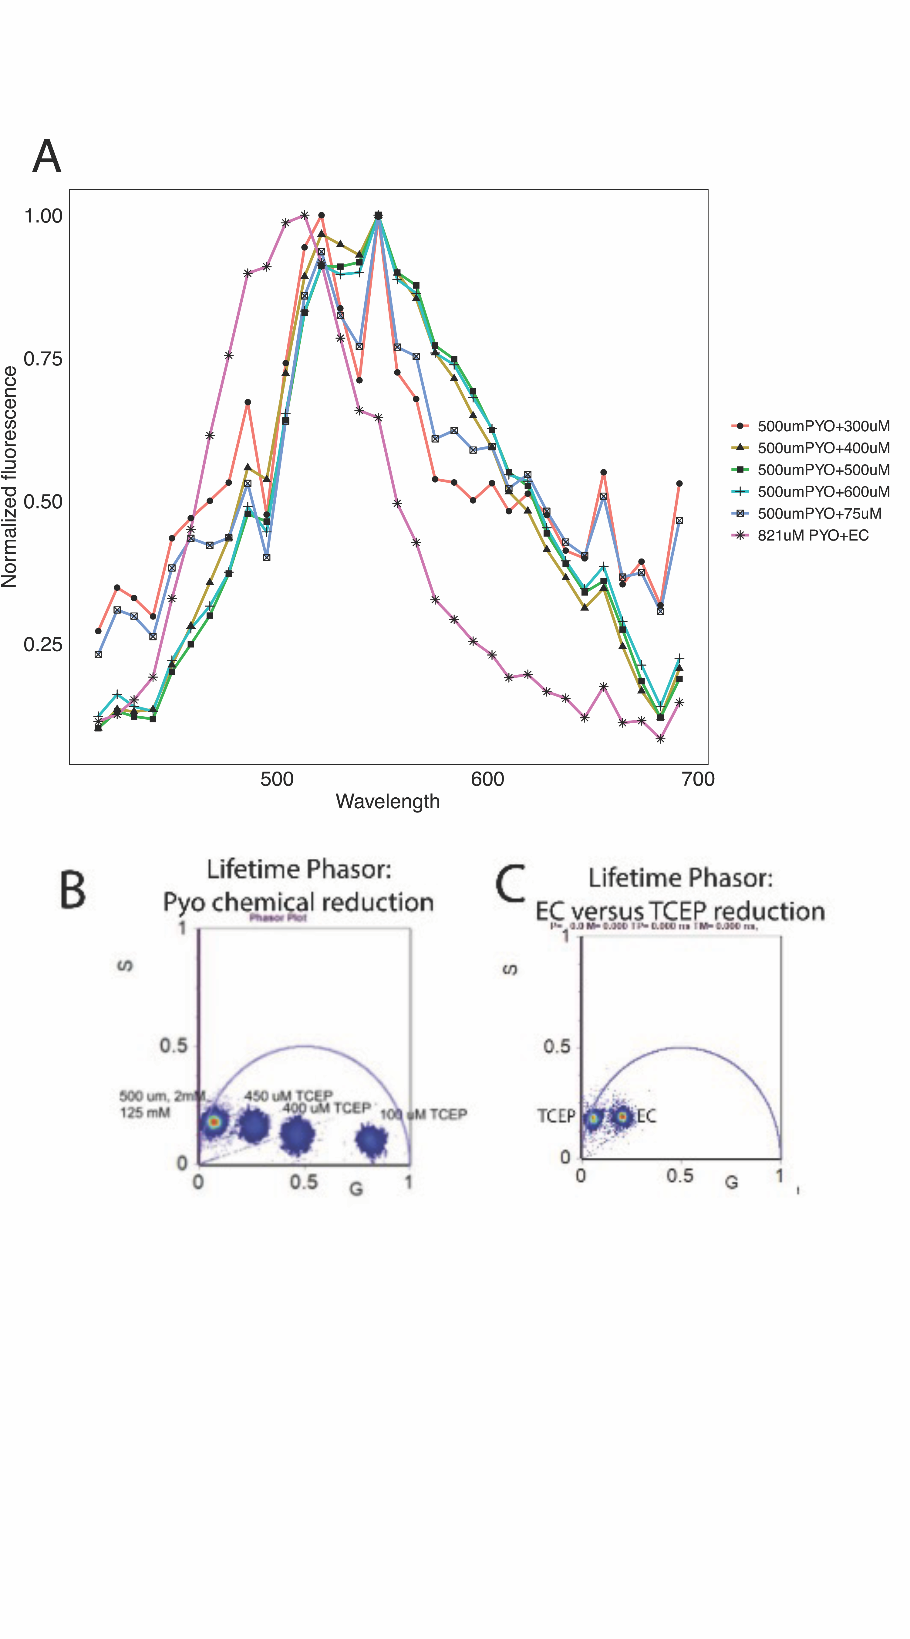

**Figure S2:** (A) Two-photon fluorescence spectra (excitation of 740 nM) of 500 µM pyocanin when reduced with a gradient of TCEP or of 821 µM pyocyanin electrochemically reduced (EC). The fluorescent emission spectra of electrochemically-reduced pyocyanin was shifted slightly to the left (longer wavelength) of TCEP-reduced pycoanin (1:1 pyocanin:TCEP ratio). (**B**) Flourescence lifetime phasor signal of 500 µM pyocanin when treated with a gradient of TCEP. As the amount of TCEP increased, the phasor signal shifted further to the left. (**D**) 1:1 TCEP-treated pyocyanin had a phasor signal shifted further to the left than electrochemically reduced pyocyanin.

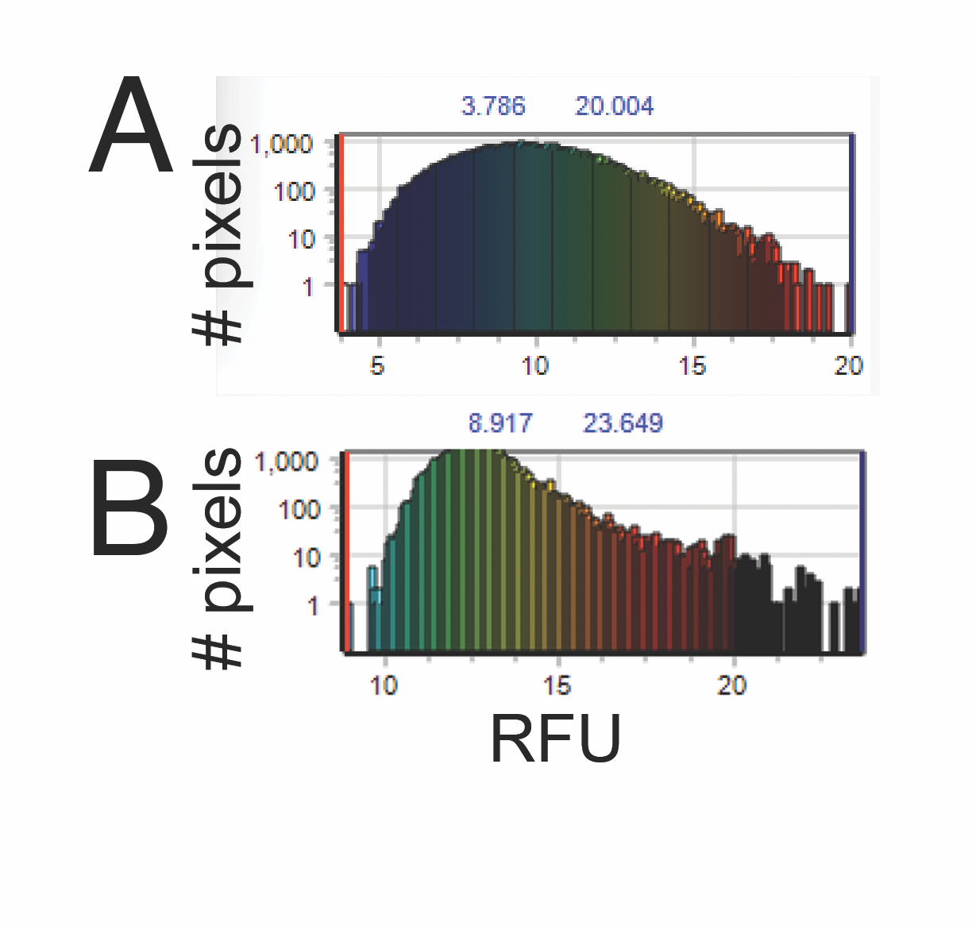

**Figure S3**: While imaging across *P. aeruginosa* biofilm depths, laser power was increased in a step-wise fashion to account for signal attenuation (20% to 59%). The fluorescent intensity across different biofilm depths was similar. (**A**) Example of fluorescent intensity from an image of the biofilm surface. (**B**) Example of fluorescent intensity histogram from an image 1 mM into the biofilm.

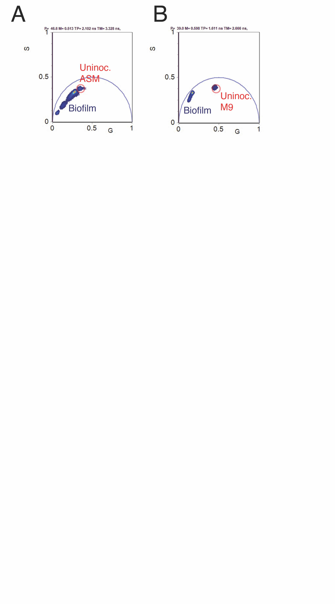

**Figure S6**: The fluorescent lifetime (FLIM) signal of un-inoculated agar is distinct from that of *P. aeruginosa* PA14 biofilms. FLIM phasor signal of (**A**) un-inoculated artificial sputum medium (ASM) agar (red circle) compared to *P. aeruginosa* PA14 biofilms in ASM agar and (**B**) un-inoculated M9 succinate agar (red circle) compared to *P. aeruginosa* PA14 biofilms in M9 succinate agar.

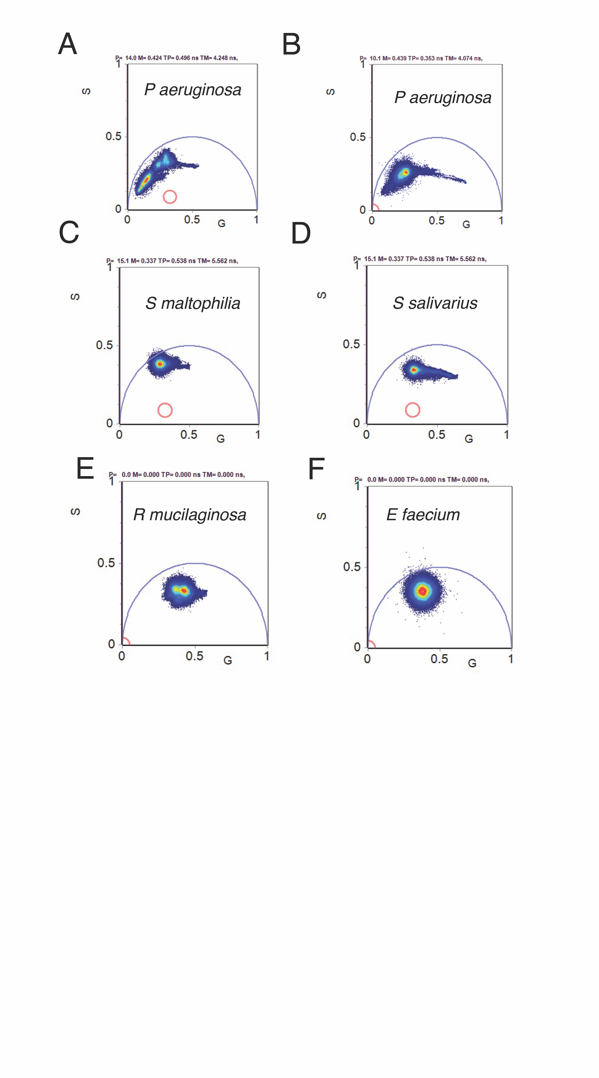

**Figure S5**: The fluorescence lifetime (FLIM) signal of *Pseudomonas aeruginosa* can be longer than that of other microbes. FLIM phasor signal of (**A**) *P. aeruginosa* PaFLR01 grown in M9 succinate with *Rothia mucilaginosa* RmFLR01supernatant in hypoxic conditions (7 images). (**B**) *P. aeruginosa* PaFLR01grown in artificial sputum medium (ASM) in hypoxic conditions (7 images). (**C**) *Stenotrophomonas maltophilia* FLR19 grown in Todd-Hewitt Broth (THB) in aerobic conditions (8 images). (**D**) *Streptococcus salivarius* FLR01 grown in THB in anoxic conditions ( 5 images). (**E**) *Rothia mucilaginosa* RmFLR01 grown in ASM in hypoxic conditions (14 images). (**F**) *Enterococcus faecium* TX1330 grown in THB in anoxic conditions (6 images).

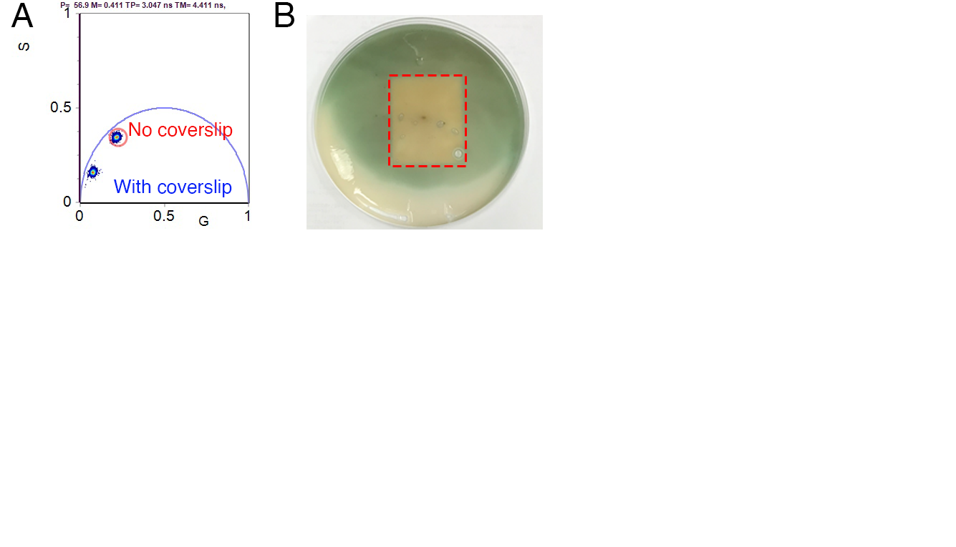

**Figure S6**: (**A**) When imaged with an air objective, the lifetime signal of the *P. aeruginosa* PA14 WT biofilm surface with a coverslip was longer (closer to the phasor origin) than that of the biofilm surface without a cover slip. (**B**) The color of the *P. aeruginosa* PA14 WT biofilm surface changed within minutes after addition of a coverslip.